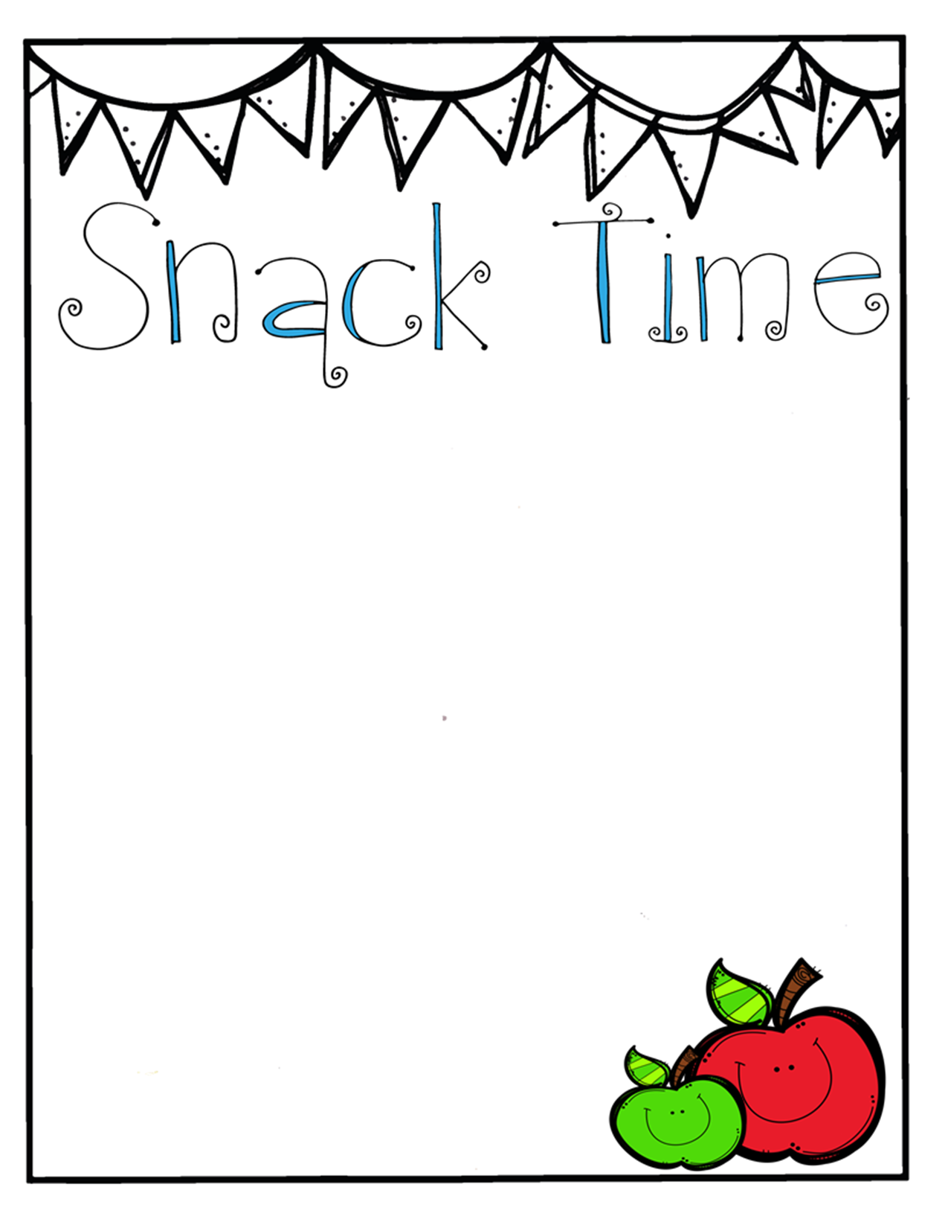

Dear Parents,
We will be providing your children with snack time during nursery/children’s church. We are asking for your help to do this. Please help us by bringing something off the following list. We prefer individually wrapped, but it is not necessary. We appreciate any help you can give.

Pretzels Animal crackers Goldfish crackers
Muffins Crackers Graham Crackers
Juice Boxes Juice Caprisuns

Thank you for your support

Sincerely,
Children’s Ministry Director
Talisha Smith

